Manual for Star Salvation
- This is a curtain shooting game, girls in Gensoukyo(幻想郷) lives a normal life after solving many of the ihen(異変)(issues). However, one day, near the forest of mist, there is suddenly a shadow of castle that appears, which seems weird. Reimu Hakurei and Marisa Kirisame both decide to go and check. The first girl that looks suspicious is Sanae, who comes from the outer world. Maybe she knows something about it…

How to play:

- What you must do is to use the arrow keys to manipulate the girls to doge the bullets:
- 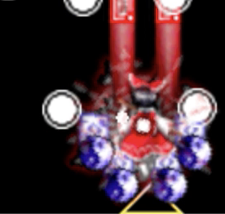
Only the center white part count as hitbox

- Hold “Z” to keep shooting, and when you want precise movement, hold “left Shift” to have a lower moving speed. Press “X” to release the boom, which can damage the enemies and provide you immune frames.
- Collect a variety of items in order to gain more score, and fire power. Items will automatically follow the player they get close enough. If shift is pressed, the range of it will be even larger. If you take risks to go to the top part of the stage, all the items on the screen will follow you at once.

Stage Structure:
- First you will encounter the mid path enemies, after around 1 minutes, you will meet the midpath Boss. You have to defeat the boss and come to the end of the stage, there is going to be a big boss for you to challenge.
- For boss, there are 2 ways to attack you. First is the none-spell, which is the boss’s regular bullet pattern. It won’t give you extra bonus.
Next is the spell attack. There will be the name of the spell and bonus displayed on the top right corner. If you manage to defeat a spell without using boom and without miss (being hit), you will be grant an extra bonus.
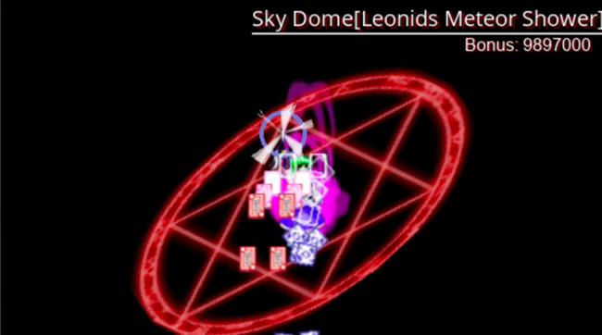
A boss is releasing a spell attack
- If you lose all your 2 lives, you can choose continue(The first line) to give you 2 extra lives. However, your score will be back to “0”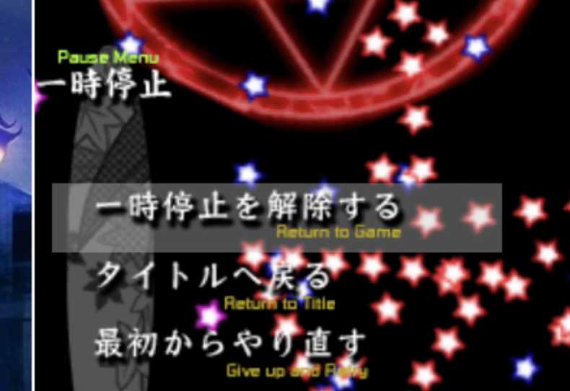
- Side bar stats:

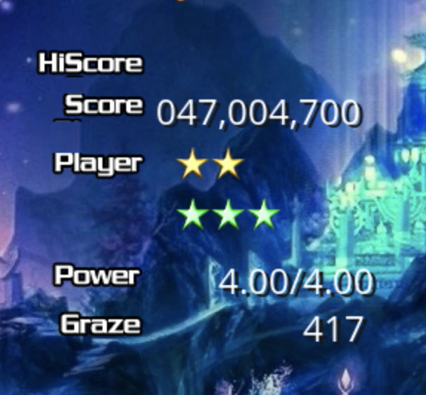
High score
Your score

Life remains
Boom remains

Fire power
Graze: getting closer to a bullet will increase graze, which give you some higher score rate
Double click “DADmain.py” to start the game

